**Chapter 2: Transcriptomic analysis of diurnal and seasonal cycles in *Ostreococcus tauri***

High-throughput transcriptome sequencing produced approximately 10 million short reads per sample (Appendix 1). This allowed us to accurately estimate gene expression levels measured as FPKM (Fragments Per Kilobase of exon per Million reads mapped) in the transcriptomes corresponding to each data point of the time series. Indeed, out of the 7668 genes currently annotated in the *Ostreococcus tauri* genome (Blanc-Mathieu et al., 2014; Palenik et al., 2007)⁠, only 3 genes were never expressed and 260 genes never exceeded an expression level of 10 FPKM. This shows that practically the entire *Ostreococcus tauri* genome is expressed under seasonal and diurnal cycles. First, we focus in the 36 transcriptomes corresponding to the time points taken during three days under LD and SD conditions and perform a hierarchical clustering analysis. (explicar que es?) The transcriptomes corresponding to the same time points during the three different days clustered together (Fig. 19-1). This indicates a high circadian synchronization in the cultures. Moreover, these 36 transcriptomes assemble into three different groups (Fig. 19-1). The first cluster corresponds to midday, when irradiance is maximum, grouping the time points ZT4 and ZT8 under LD and ZT4 under SD. The second cluster conforms the dusk group. Here, the transcriptomes at time points ZT12 and ZT16 under LD and ZT8 under SD are grouped, coinciding with the end of the light period, when incident irradiance is low. The third cluster represents night/dawn and comprises the transcriptomes at time points ZT20, ZT0 under LD and ZT12, ZT16, ZT20 and ZT0 under SD. The transcriptomes at time points in the LD and SD nights or dark periods constitute two distinct groups suggesting noticeable differences in the transcriptomic responses during the night under LD and SD conditions. It is also noteworthy the higher similarity between the dusk, night/dawn transcriptomes when compare to the midday one (Fig. 19-1).

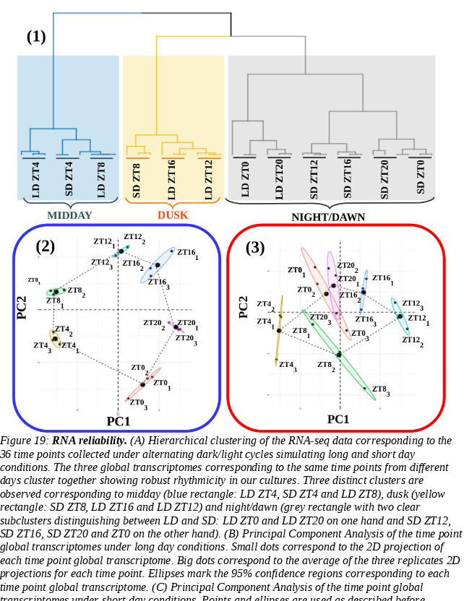

In order to obtain a deeper understanding of the underlying structure in our data we performed principal components analysis separately, over the LD (Fig. 19-2) and SD (Fig. 19-3) transcriptomes. Under LD condition, the transcriptomes corresponding to the same time point in the three different days tightly cluster together globally, constituting a circular structure. Nonetheless, under SD conditions, more variability is observed and the time point transcriptomes form a structure resembling an ellipse. This could indicate that whereas in LD conditions gene expression in globally cycling precisely with a similar period, a more complex behavior is expected under SD conditions. In addition, it is remarkable the high similarity between the transcriptomes corresponding to ZT0 and ZT20 under SD conditions that is not present under LD conditions. This would suggest that the transcriptomic response at the end of a SD night is already preparing all molecular systems for the incoming light availability at dawn, whereas this anticipation is not so evidently observed under LD conditions. In overall, these results support that the experimental design grants a high level of synchronization in the data, allowing to proceed to the identification and comparison of genes exhibiting rhythmic expression patterns under LD and SD conditions.

* **Transcriptomic characterization of diurnal rhythmic expression profiles**
* ***Most genes in Ostreococcus tauri present diurnal rhythmic expression profiles under both photoperiods***

We used the bioconductor R package RAIN (Rhythmicity Analysis Incorporating Non-parametric Methods) (Thaben & Westermark, 2014)⁠, as described in Materials and methods, to identify genes exhibiting diurnal rhythmic expression patterns under both seasonal conditions. Specifically, we used time series consisting of three days with rhythmic light / dark periods from our experiment. Independently from the photoperiod, more than 6000 genes comprising approximately 80% of the entire *Ostreococcus* genome present diurnal periodic rhythmic expression patterns. This result is in agreement with previous studies in *Ostreococcus tauri* (Monnier et al., 2010)⁠ under different photoperiodsand other microalgae such as *Chlamydomonas reinhardtii* (Zones et al., 2015)*⁠*.  The specific rhythmic genes under each photoperiod are practically coincident (Fig.  20-A) (Supplemental Table 3—ANEXO?).

In order to explore the remaining 20% of the genome of *Ostreococcus tauri* that did not show rhythmic expression patterns under any photoperiod, we compared their highest expression values with the ones reached by rhythmic genes. Genes exhibiting rhythmic expression patterns under both LD and SD conditions present a maximal level of expression three times greater than genes detected as non rhythmic. This difference was significant according to a p-value of 1.45×10-4 computed using Mann-Whitney-Wilcoxson test (Fig. 20-B). The current methods for detecting rhythmic gene expression are known to perform optimally only for highly expressed genes (Laloum and Robison-Rechavi, 2020). Therefore, the genes identified as non rhythmic in this study could indeed be rhythmic although their low expression level have prevented our methods from detecting them.

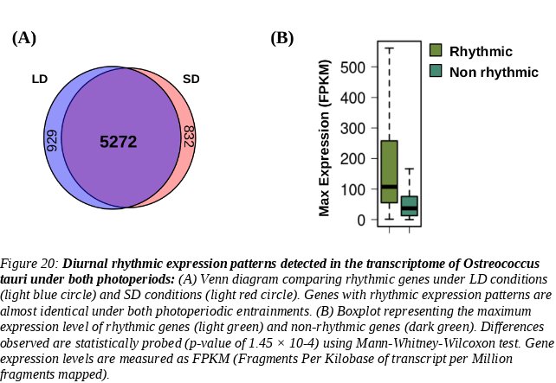

* ***Constant light and constant darkness as free-running conditions have different effects over the transcriptome of Ostreococcus***

In order to distinguish between oscillating genes predominantly regulated by the circadian clock, *bona fide* circadian genes, from those genes that exhibit oscillations as a response to the alternating light/dark cycles free running conditions consisting of constant light and constant dark were considered. The effect of the transition to constant light (LL) or dark (DD) on rhythmic gene expression patterns was performed using the co-sinusoidal parametric method implemented in the R package *circacompare*. Two rhythmic parameters, amplitude and phase, were compared between the expression profiles under LD or SD to the corresponding ones under LL and DD

When comparing LD and LL gene expression patterns, an amplitude decrease in the rhythmic expression profiles was observed. Specifically, most LL rhythmic genes after LD entrainment (97.68%) that presented a decrease in amplitude when transferred to LL (Fig. 21-A), being significant in more than half of them. A positive (forward) phase shift (increasing phase) is observed under LL when compared to LD in 76.28% of LL rhythmic genes being significant in 14.98% of them. In contrast,, when comparing LD with DD gene expression patterns, the reduction in amplitude is less widespread (Fig. 21-A), being observed in 79.43% of the DD rhythmic genes with significance in 31.62% of them. Opposite to the LL effect, negative (backward) phase shifts (decreasing phase) were observed in DD rhythmic gene expression profiles. Specifically, 87.32% of the DD rhythmic genes after LD entrainment presented an anticipation in phase that was significant in 34.16% of them. Most of them present negative (backward) phase shifts between 0 and 5 h of difference, whereas most of genes presenting positive (forward) phase shifts under LL condition exhibit between 0 and 5 h of difference (Fig. 21-B).

The global reductions of LL and DD amplitude in rhythmic gene expression profiles when compared to LD amplitude (Fig. 21-A) are significant with p-values 4.23×10-140 and 1.09×10-60 respectively. More precisely, the reduction in amplitude is significantly lower under LL than under DD with a p-value of 6.71×10-28.

Next we analyse free-running conditions effects over rhythmic genes with previous SD entrainment. First, comparing their expression profiles under SD and LL, it can be observed that amplitude decrease is more drastic than the one observed for LD entrainment. Specifically, most LL rhythmic genes (87.9%) presented a drastic decrease in amplitude when transferred to LL (Fig. 21-E), being significant in 34.6% of them. Similar to the behaviour after LD entrainment, a positive (forward) phase shift around 5 h of difference (Fig. 21-F,G) was also observed in 68.28% of LL rhythmic genes after SD entrainment, being significant in 14.98% of them. However, when comparing SD and DD gene expression patterns, the reduction in amplitude was almost non-existent (Fig. 21-E), being observed only in 35.97% of the DD rhythmic genes with significance in 23.58% of them. Negative (backward) phase shifts were observed in 47.7% of the DD rhythmic genes after SD entrainment with significance in 28.83% of them. Nonetheless, globally most genes have a phase shift around 0 (Fig. 21-F), suggesting that phase is not drastically affected under DD after SD entrainment (Fig. 21-G).

The global drastic amplitude reduction in LL rhythmic gene expression profiles after SD  entrainment was significant with a p-value 5.95×10-65 (Fig. 21-D). In contrast to what was observed after LD entrainment, a slight but significant increase in amplitude under DD was detected when compared to SD with a p-value of 2.50×10-8 (Fig. 21-D). There are no drastic changes in phase or amplitude in DD rhythmic expression profiles after SD entrainment. This suggests a highly similarity between SD and DD conditions, probably due to long periods of dark entrainment.

Free-running conditions have been widely studied in nocturnal mammals (Bartoszewicz et al., 2010; Hundahl et al., 2012; Imai et al., 2020)⁠, plants (Edwards et al., 2010; Ohara et al., 2015)⁠ and other organisms (Biebach et al., 1991; Vatakis et al., 2018)⁠. The effect over the amplitude of biological rhythms has been previously observed at different biological levels and is commonly associated with a loss of synchrony (Paajanen et al., 2021; Vatakis et al., 2018)⁠ (Fig. 22). This suggests that LL conditions promote a larger loss of synchrony than DD conditions at the transcriptomic level in *Ostreococcus* under both photoperiods of entrainment.

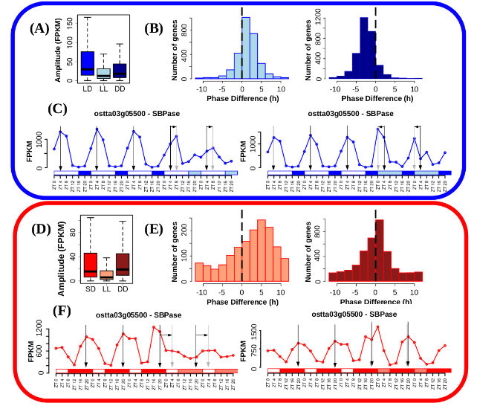*Figure 21:* ***Free running conditions effects over gene expression profiles.*** *(A) Boxplot representing rhythmic genes amplitude reached under long day condition (blue), when cultures were kept under free running condition consisting of constant light (light blue) and when cultures were kept under free running condition consisting of constant dark (dark blue). LL and DD amplitudes are significantly reduced with respect to LD according to p-values of 4.23×10-140 and 1.09×10-60 possibly due to a decline in culture synchrony under free running conditions. LL amplitudes are also reduced when compared to DD according to a p-value of 6.71×10-28 suggesting more severe loss of rhythmicity under LL than DD. P-values were computed using Mann-Whitney-Wilcoxon test. (B) Histograms showing the distribution of the number of genes exhibiting positive and negative phase shifts under LL (light blue, left) and DD (dark blue, right) free running conditions when compared to LD. Vertical dashed lines mark no shift. Positive (forward) phase shifts are observed when cultures are transferred from LD to LL whereas negative backward phase shifts are apparent when transferred to DD. (C) Gene expression profiles under LD, LL and DD of Sedoheptulose-bisphosphatase (ostta03g05500, SBPase). Vertical black arrows mark LD phases, vertical grey arrows mark LL and DD phases and horizontal black arrows represent phase shifts. SBPase illustrates how genes after LD entrainment present reduced amplitudes under LL and DD, forward phase shifts under LL and backward phase shift under DD. (D) Boxplot representing rhythmic genes amplitude under short day condition (red), when cultures were kept under free running condition consisting of constant light (light red) and when cultures were kept under free running condition consisting of constant dark (dark red. P-values were computed using Mann-Whitney-Wilcoxon test. (E) Histograms showing the distribution of the number of genes exhibiting positive and negative shifts in phase or maximum expression level time point under LL (light red, left) and DD (dark red, right) free running conditions when compared to SD. Vertical dashed lines mark no shift.. (F) Gene expression profiles under LD, LL and DD of Sedoheptulose-bisphosphatase (ostta03g05500, SBPase). Vertical black arrows mark SD phases, vertical grey arrows mark LL and DD phases and horizontal black arrows represent phase shifts. SBPase illustrates how genes after SD entrainment present reduced amplitudes and forward phase shifts only under LL with no significant change under DD.*

The free-running rhythms observed in *Ostreococcus* are possibly found in other photosynthetic organisms as well. There is a huge lack of research of this topic but positive and negative phase shifts under LL and DD, respectively, have been also observed in algae-coral symbiosis content in photosynthetic pigments (Sorek et al., 2013)⁠.

However, since plants growth is dependent on photosynthesis and thus on light, the effects of DD conditions over biological rhythms in photosynthetic organisms are yet poorly described. Light is currently considered the primary transcriptional zeitgeber or synchronizing signal in plants disregarding the relevance of dark periods in regulating diurnal rhythms (Wenden et al. 2011 Light inputs shape the Arabidopsis circadian system, Wang et al. 2022 Circadian entrainment in Arabidopsis) Our results provide evidence, in agreement with other studies (), of the importance of dark periods in synchronizing diurnal cycles in the green lineage. In contrast, to other photosynthetic organisms (Okada et al. 2017 Synchrony of plant cellular circadian clocks with heterogeneous properties under light/dark cycles), in Ostreococcus LL conditions exerted a stronger desynchronizing effect than1 DD conditions. Moreover, the LL and DD effects observed over the transcriptomes of *Ostreococcus* in this study (desynchronization, positive phase shifts under LL and negative phase shifts under DD) are typically described in nocturnal animals. Also, constant light is commonly used as a circadian disruption model in nocturnal organisms (Bartoszewicz et al., 2010; Hundahl et al., 2012; Imai et al., 2020; Vatakis et al., 2018)⁠, similar to the strongly desynchronizing effect over the transcriptome of *Ostreococcus*. This suggests for the first time a strong dependence on dark periods in *Ostreococcus* and a predominant nocturnal character of its transcriptome.

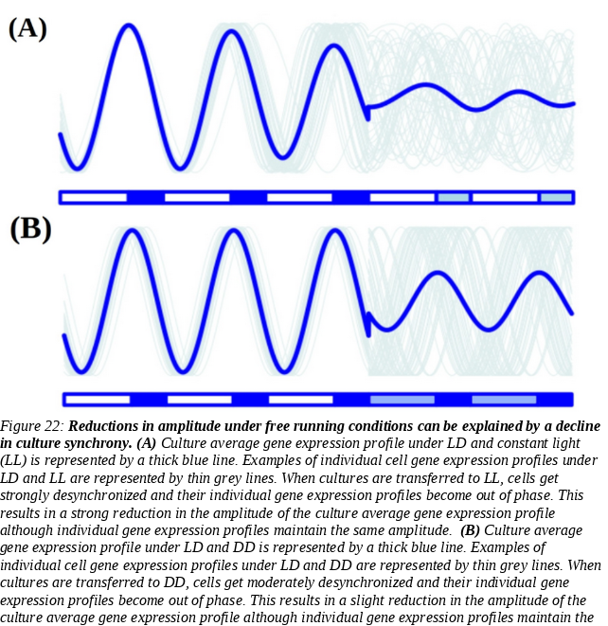

* ***Under free running conditions rhythmicity is maintained in different proportions depending on the photoperiod of entrainment***

As it was described previously in the introduction, *bona fide* circadian processes are self-sustained and maintain their rhythmicity even when their specific zeitgeber, or synchronizing environmental signal, becomes constant. Following this definition, *bona fide* circadian genes can be identified and distinguished from light or dark responding ones from data generated under free-running conditions consisting in constant light (LL) and constant dark (DD). This also allows to identify rhythmic genes sets for which the main zeitgeber is light or dark as those maintaining rhythmicity under constant light (LL) or constant dark (DD) respectively. One of the main observations is that the maintenance of rhythmic expression profiles is dependent on the photoperiod of entrainment. This supports the key role played by seasonality in establishing the global state of Ostreococcus transcriptomes.

Although genes with rhythmic expression profiles under LD (6201 rhythmic genes) and SD conditions (6104 rhythmic genes) were almost coincident (Fig. 20-A), their rhythmicity was not maintained equally under free running conditions. Specifically, 2804 genes (36.57% of the entire genome) with a previous LD entrainment maintained their rhythmicity under constant light (LL) conditions (Fig. 23-A). The number of genes that after SD entrainment maintained their rhythmicity under LL conditions decrease to 1526 (19.9% of the entire genome) (Fig. 23-C). However, 3311 genes after LD entrainment and 4006 genes after SD entrainment maintained their rhythmicity under constant dark conditions (DD) (Fig. 23-A,C). This indicates that constant dark has a synchronizer effect over a larger part of the Ostreococcus transcriptome than constant light. In other words, that dark is the main zeitgeber for the expression of more genes than light. This was specially evident for rhythmic gene expression under SD conditions which was found very dependent on the presence of a dark period or skotoperiod.

Regulatory mechanisms are often composed of large networks influenced by a wide range of inputs. Circadian clocks are strongly influenced by external environmental signals but there exists a complex interplay between the clock and cell physiology as well (Mazzoccoli et al., 2020; Morris et al., 2020)⁠. Genes maintaining their rhythmic expression profiles only under LL or DD are partially regulated by diurnal changes in the circadian clock. They are influenced by other regulatory mechanisms as light (Fig. 23-B) or dark (Fig. 23-D).

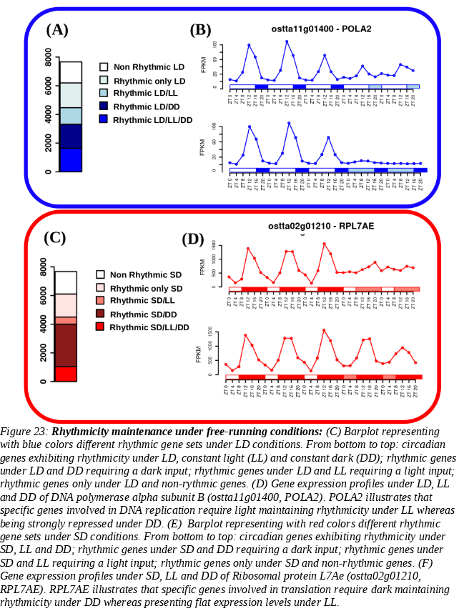

For example, one of the enriched GO biological processes in the set of genes that maintain their rhythmicity only under LL, for which light is the primary zeitgeber, was DNA replication (ANEXO). It agrees with previous cell cycle studies in microalgae like *Euglena* (Kato & Nam, 2021)⁠*,*  *Chlamydomonas* (Donnan & John, 1983; Zones et al., 2015)⁠and *Ostreococcus* (Moulager et al., 2007, 2010)⁠, suggesting that cell cycle have a strong circadian clock regulation as well as G1 phase is light-dependent due to the need of light to grow in photosynthetic organisms. This provides evidence for the need of a light input to maintain rhythmicity in genes involved in DNA replication. Wherea, the main enriched GO biological processes in the set of genes that maintain their rhythmicity only under DD are RNA processing and ribosome biogenesis (ANEXO). These processesare known have a complex regulatory mechanism influenced by the circadian clock as well as other regulatory machinery. They are commonly programmed at transcriptomic level to take place during the night, so translation of proteins can be achieved during the day (Merchant et al., 2017)⁠. Therefore, It is expected that a dark input is needed to maintain rhythmicity in those genes since their activation is dark-dependent.

In addition, comparison of the gene sets maintaining rhythmicity under both DD and LL free-running conditions after both, LD and SD entrainment, allow us the identification of what is called *bona fide* circadian genes (Fig. 24-A). *Bona fide* circadian rhythms are predominantly regulated the ones maintained under every condition (both photoperiods of entrainment and both free-running conditions) and are mainly regulated by diurnal changes in the circadian clock. In our data, there are only 350 genes (comprising 4.6% of the entire *Ostreococcus* genome) that do not present either a flat or noisy profile under any of the studied conditions. Gene expression profiles of RuBisCO activase (ostta04g02510, RCA) under the different conditions exemplifies how *bona fide* circadian genes maintain their rhythmicity (Fig. 24-B).

A functional GO enrichment analysis over this set of genes showed that they are mainly involved in the biological processes photosynthesis, chlorophyll metabolic/biosynthetic process and chloroplast organization, among others (Fig. 24-C). Some of those processes are known to present a circadian physiological activity in plants and microalgae like *Euglena,* but there is a lack of confirmation at the transcriptomic level in most cases like the one provided here for Ostreococcus (Cumming & Wagner, 1968; Noordally & Millar, 2015; Panter et al., 2019)⁠.

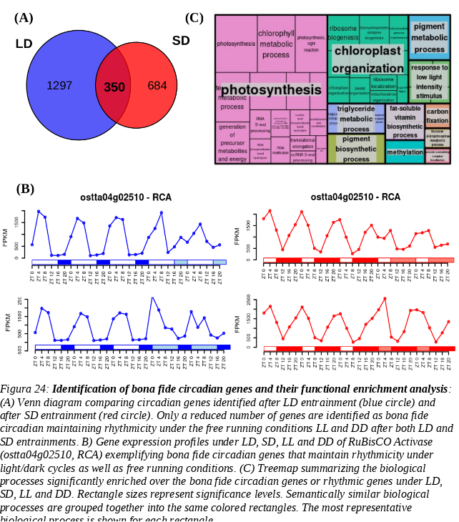

* **Transcriptomic characterization of seasonal  effects over gene expression profiles**
* ***Seasonal changes induce changes in amplitude and phase over gene expression profiles.***

R package circacompare is used to study the global effect of the photoperiod over the amplitude and phase of rhythmic expression profiles. Photoperiodic dependent changes in amplitude and phase shifts in biological rhythms have been already described in mammals (Messager et al., 2000; Sumová et al., 2003; Van Dongen et al., 1997; Wucher et al., 2022)⁠, as well as in plants and microalgae (Flis et al., 2016; Panter et al., 2019; Serrano et al., 2009)⁠. Depending on the organisms under study increments o decrements in amplitude as a response to shortening or lengthing photoperiods have been reported. Specifically, when biological rhythms are studied globally in *Arabidopsis thaliana*, phase shifts as an adaptation to changes in photoperiod has been described but no changes amplitude were observed (Flis et al., 2016)⁠. A similar effect is observed in *Chlamydomonas* in specific genes(Serrano et al., 2009)⁠.In both studies, differences in amplitude are only found in some biological rhythms when they are studied individually. For example, the rhythmic expression profile of the gene *CrCO* potential ortholog of the *CONSTANS* gene in Arabidopsis thaliana shows an increase in amplitude under SD conditions as well as a negative (backward) phase shift.

In *Ostreococcus* transcriptome, global changes affecting the amplitude in gene expression patterns have been found. Specifically, SD amplitudes are significantly reduced with respect to LD according to a p-value of  1.16e10-111 computed using Mann-Whitney-Wilcoxon (Fig. 25-A). A high number of rhythmic genes (2036 genes) exhibited a significant amplitude decrease in their rhythmic expression profiles, whereas, only 123 significantly increased their amplitude. This suggests a decline in culture synchrony under SD, accordingly to the previous similar synchronization observed between DD and SD conditions (Fig.21-D).

Negative phase shift or phase anticipation were also globally observed over the transcriptome of *Ostreococcus*, in agreement with what has been described in *Arabidopsis* and *Chlamydomonas* for some specific genes (citas). Specifically, 3424 genes comprising 64.95% of the rhythmic genes exhibited a significantly anticipated phase under SD condition when compared to LD condition. Phase anticipation were apparent under SD since gene phases are mostly reached around SD midnight (ZT12 to ZT16) whereas, under LD, phases are uniformly distributed from LD dusk (ZT12) to the end of the night (Fig. 25-B). Only a low number of rhythmic genes exhibit their phase or maximum level of expression during the light period in LD and SD. This indicates that the main activity at the transcriptomic level takes place during the night in *Ostreococcus,* which supports the nocturnal character of its transcriptome as described previously when analyzing the effects of free running conditions, namely, desynchronization and positive (forward) phase shifts under LL and increase in synchronization and negative (backward) phase shifts under DD.

Figure 25-C shows expression profiles of *Cyclin B* (*ostta01g06150*, *CYCB*) and *Delta-9 acyl-lipid desaturase 1* (*ostta01g00790*, *ADS1*) as two examples of genes exhibiting the typical phase anticipation and amplitude reduction under SD condition when compared to LD condition.

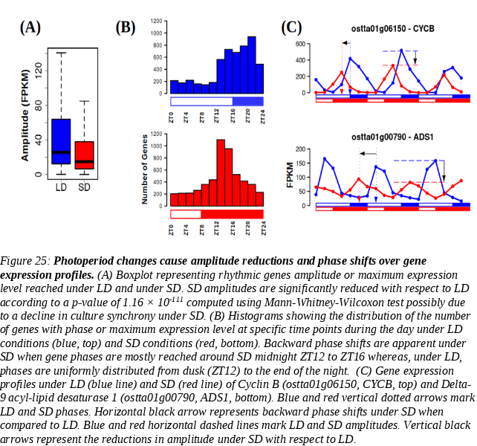

* ***Seasonal changes promote the emergence of 12 h period***

When comparing SD and LD conditions, another phenomenon has been identified in the transcriptome of *Ostreococcus* emerging as a response to photoperiod shortening.Under LD condition, almost every rhythmic gene (5825 genes covering 75.97% of the entire genome) reache its maximum level of expression once a day, presenting one single peak every 24h in its expression profile (Fig. 26-D, E). Under SD conditions the number of genes presenting one single expression peak per day decreases to 4249 (55.41% of the entire genome). This is coupled to an increasing number of genes, namely 1855 genes, presenting a more complex rhythmic expression profile with two expression peaks per day (every 12 h) (Fig. 26-D, E).

Biological rhythms with 12 h periods (two peaks per day) have been described from marine organisms to mammals including humans. It is hypothesized that 12 h rhythms in gene expression and metabolism in terrestrial organisms is reminiscent of the ~ 12 h circatidal rhythms of coastal and estuarine organisms (Ballance & Zhu, 2021)⁠. The maintenance of 12 h rhythms after evolving to live on land is hypothesized to provide an advantage in the adaptation to metabolic stress that peak at transition periods during the diurnal cycle (Pan et al., 2020; B. Zhu et al., 2017)⁠.

Bimodal rhythms presenting two peaks per day not necessarily separated by 12h that are maintained under free running conditions have been observed in animals (Binkley & Mosher, 1985; Foà & Bertolucci, 2001; Kyorku & Brady, 1994; Prabhakaran & Sheeba, 2012; Watanabe et al., 2007)⁠, plants (Hayes et al., 2010; Van Gelderen, 2020)⁠ and some microalgae, like Euglena (Mohabir & Edmunds, 1999)⁠. Nevertheless, they have been described only for specific processes, genes or compounds not being identified as a global response in the transcriptome to external signals. Seasonal cycles were thought to have some effect over these rhythms but, in the majority of the studies, different photoperiods were not studied or no difference between them was detected (Prabhakaran & Sheeba, 2012)⁠. There is only an observation of a bimodal biological rhythm detected in ruin lizards that is apparently strongly dependent on photoperiod length and is also maintained under free-running condition (Foà & Bertolucci, 2001)⁠. Nonetheless, 12 h period rhythms in gene expression emerging under shorter photoperiods have gone mostly unnoticed and thus there is no hypothesis about its biological role so far. We have found this type of rhythmic gene expression when reanalyzing already published transcriptomic data. As an example, bimodal gene expression patterns were identified in a published microarray data set generated from cultures of *Ostreococcus tauri* under neutal day conditions (12 h light:12 h dark) (Monnier et al., 2010)⁠. Most of the rhythmic genes presented rhythmic expression profiles with a 24 hours period and, thus, a single expression peak. However, 1171 genes presented rhythmic expression pattern with an apparent period of 12 hours (two peaks of expression per day). This photoperiod can be considered an intermediate step between the two extreme photoperiods studied in this thesis (LD and SD). Indeed, the data show an intermediate number of genes with two peaks of expression per day between the ones identified in this thesis for LD and SD conditions. Also, in agreement with our results, this type of rhythmic patterns can be found in data generated from other organisms like *Chlamydomonas* under neutral day (Zones et al., 2015)⁠. This suggests that, at least in *Ostreococcus* (and possibly other microalgae), there is an increasing number of genes that reach their maximum level of expression twice a day (every 12h) as the photoperiod get shorter although its biological role remains to be determined.

Tides play a central role in the dynamics of the natural environment of  *Ostreococcus* as a marine organism. Tides take place following rhythms of approximately 12 h and can give rise to circatidal gene expression patterns. These rhythms must persists under free running conditions. This was discarded in our case since the observed 12 h period rhythmic gene expression profiles  in *Ostreococcus* transcriptome under SD are not maintained under free-running conditions. Instead, bimodality disappears and only one of the expression peaks was maintained under constant light whereas the other one persisted only under constant darkness (Fig. 26-C).

Our results suggest that the seasonal effect observed over the transcriptome of *Ostreococcus* is not a self-sustained 12 h rhythm, but a combination of two distinct rhythmic profiles: one dependent on the photoperiod (maintaining its rhythmicity only under LL) and another one sustained by the skotoperiod (maintaining its rhythmicity only under DD). This was supported by a decomposition performed over the bimodal gene expression profiles present under SD conditions into two co-sinusoidal unimodal profiles. Indeed, each one of the profiles was coincident with the one maintained under LL and DD respectively. Moreover, this decomposition produces a possible explanation for the presence of bimodality under SD conditions and its absence under LD conditions. Whereas the light-dependent expression profile does not change as the photoperiod shortens the dark-dependent expression profile is shifted as the skotoperiod lengthens. In this way, under LD both profiles are coincident in phase and they cannot be distinguished from one another. Nevertheless, as the skotoperiod lengthens the phase of the dark-dependent profile is shifted. Therefore, both profiles become out of phase under SD conditions unveiling a joint but independent regulation exerted by the photoperiod and skotoperiod in the expression of the corresponding gene. (Fig. 26-C).

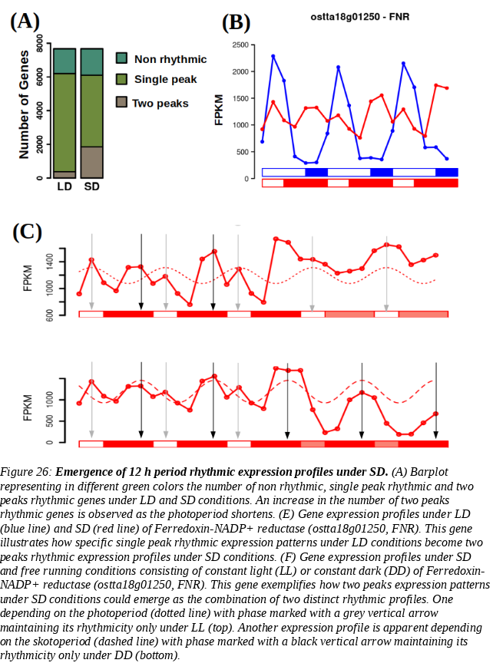

* ***Seasonal cycles induces distinct temporal transcriptional programs organizing biological processes during diurnal cycles***

In order to determine the temporal organisation of the transcriptional program in Ostreococcus under summer LD and winter SD conditions, genes were clustered depending on their phase or time of maximum expression level. A functional enrichment analysis of the resulting gene clusters revealed the cellular processes activated at the transcriptomic level in each temporal point (supp 8 y 9 incluir estas dos figuras en el texto principal cada una en una página). Focusing on the most enriched processes in each time point, a transcriptional temporal map of *Ostreococcus* under each photoperiod is illustrated in Fig. 27.

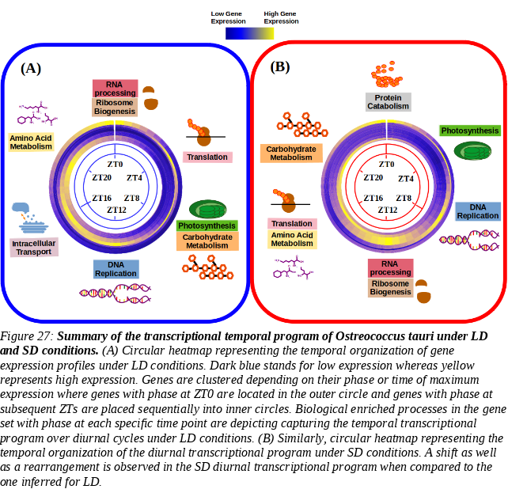

During summer days (Fig. 27-A), *Ostreococcus* activates genes involved in RNA processing and ribosome biogenesis at dawn (ZT0). Examples for such genes are *U3 small nucleolar RNA-associated protein 14* (*ostta04g00770*, *Utp14*) and the *Ribosome Biogenesis Factor BMS1* (*ostta05g01080*, *BMS1*) (Supp 8). During the first part of the morning (ZT4) *Ostreococcus* transcriptome is almost completely focused in genes involved in translation, such as *eukaryotic Initiation Factor 2* (*ostta03g02100*, *eIF2*) and *translation elongation factor P* (*ostta03g03015*, *YeiP*). The genes mainly involved in photosynthesis but also in carbohydrate metabolism reach their maximum expression level during midday, when irradiance is maximum (ZT8). Some of those genes are subunits of both photosystems: *ostta01g03170* (*PsbP*), *ostta02g00580* (*PsaL*), *ostta02g02560* (*PsbX*), *ostta02g03860* (*PsaE*), *ostta04g01790* (*PsaF*), *ostta05g04560* (*PsbR*), etc. During the afternoon (ZT12), the activation of genes involved in DNA replication takes place. Some minichromosome maintenance proteins *ostta01g02580* (*MCM6*) and *ostta05g01680* (*MCM9*)) are found, as well as the *proliferating cell nuclear antigen* *ostta06g02890* (*PCNA*) which is central to the DNA replication process. Intracellular transport and cellular respiration are the two most prominent biological processes whose genes reach their maximum expression level at dusk (ZT16) under LD conditions. Genes like *lysophospholipases ostta01g04440* (*CLC*) or *nucleoporins* *ostta14g02210* (*Nup133*) are some examples for this time point. Finally, during midnight, *Ostreococcus* focuses on expressing genes involved mainly in cellular amino acid metabolic process, like *3-Deoxy-D-arabinoheptulosonate 7-phosphate* () *synthase* *ostta06g03270*, (*DAHP*) which encodes the first enzyme in the biosynthesis of the amino acids phenylalanine, tyrosine and tryptophan.

During winter days, the most prominent biological process whose genes reach their maximum expression level at dawn (ZT0) is protein catabolism. Examples for such genes are *Signal transduction Histidine Kinase* *ostta09g02190* (*HK*), or *Ubiquitin Fusion Degradation protein* *ostta09g00750* (*UFD*). In agreement with what was observed in summer, genes having their peak of expression during midday (which in winter takes place at ZT4, maximum irradiance) are involved in photosynthesis. Once again, genes encoding photosystems subunits are clustered in this time point. Under SD conditions, dusk takes place at ZT8., Genes involved in DNA replication show their maximum level of expression during this time point. The same genes used as an example in LD are found also in SD but anticipating their peak of expression 4h. Then, RNA processing and ribosome biogenesis are the two most prominent biological processes early during the night (ZT12), showing an anticipation of 12h compared with LD temporal program. In addition, genes involved in translation also show a 12h anticipation reaching its maximum expression level during midnight (ZT16). Under LD photoperiod, genes involved in aminoacids biosyntheticc processes reach their maximum expression level at ZT20, 8h before genes involved in translation show their expression peaks (ZT4). However, under SD photoperiod genes involved in both processes seems to reach their maximum expression level at the same time. Genes involved in photosynthesis and carbohydrate metabolism reach their maximum expression level at the same time under LD (ZT8), but they take place at two different times under SD. In this condition, genes involved in photosynthesis maintain their maximum level of expression at the maximum irradiance time (which correspond to ZT4 in SD). However, genes involved in carbohydrate metabolism reach their maximum expression level 12 h later (after midnight at ZT20). This suggests that phase shifts globally observed over the transcriptome of *Ostreococcus* *tauri* as an adaptation to photoperiods, not only consist in anticipating or delaying processes but also in a rearrangement of the complete temporal program.